1. DB Upgrade

Database\DbUpgrade

1. Deploy

Wfm.Admin.dll

Wfm.Admin.dll.config

Wfm.Admin.pdb

Wfm.Client.dll

Wfm.Client.dll.config

Wfm.Client.pdb

Wfm.Core.dll

Wfm.Core.pdb

Wfm.Data.dll

Wfm.Data.pdb

Wfm.Services.dll

Wfm.Services.pdb

Wfm.Shared.dll

Wfm.Shared.pdb

Wfm.Web.dll

Wfm.Web.dll.config

Wfm.Web.Framework.dll

Wfm.Web.Framework.pdb

Wfm.Web.pdb

1. Signature Function
2. Signature Pad

Client/Supervisors draw their personal signature on Signature Pad.

Login as client/supervisor -> Profile -> Signature, will see:

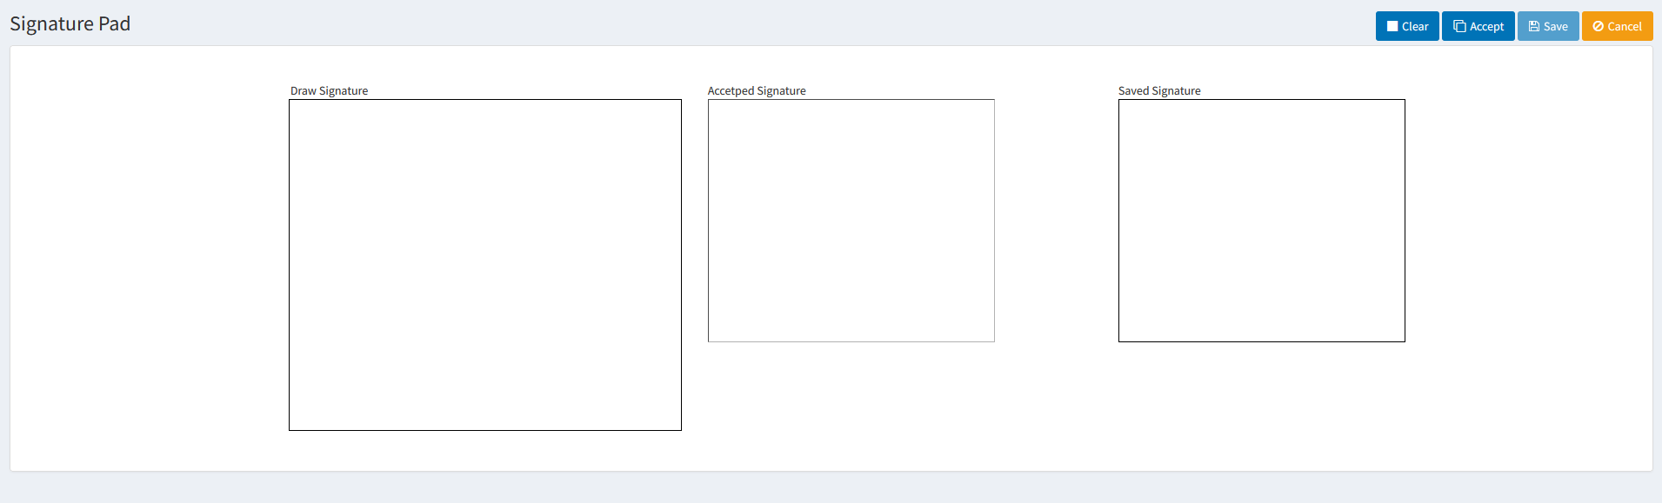

User draw the signature in the “Draw Signature” box.

Click “Clear” to discard it.

Click “Accept” to accept it, and the accepted signature will be shown in the “Accepted Signature” box.

Click “Save” to save the signature. The save signature will be shown in the “Saved Signature” box.

Click “Cancel” to exit the “Signature Pad”.

1. Configure the companies that need signature function

In table [Setting], set the value for the name “SignatureCompanies” with companyIds (separated by comma) that need signature function.

For example:

Id Name Value FranchiseId EnteredBy

129 SignatureCompanies 459,213 1 63

1. Client/Supervisors approve and sign the Timesheet

For the companies configured in the above “2”, when the supervisors approve the work hours in timesheet, they are signed with the signature saved in the above “1”.

Login as client/supervisor -> Approval



1. Client/Supervisors print the timesheet to PDF

Login as client/supervisor -> Approval



For companies configured in the above “2”, the printed PDF has signature column.

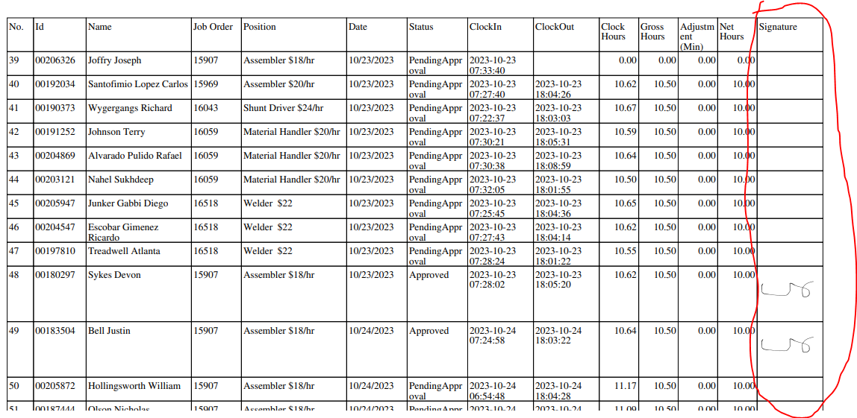

For other companies, the printed PDF doesn’t have signature column.

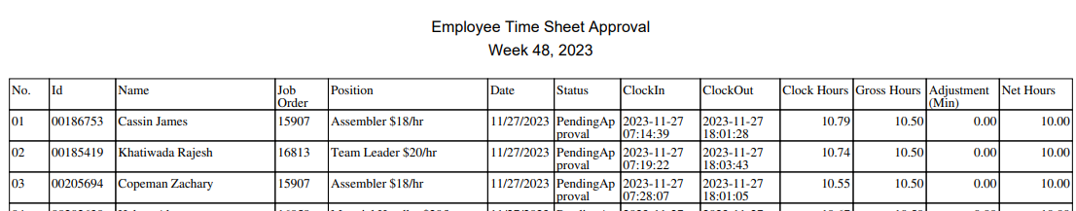

1. Admin print the “daily timesheet” to PDF

Login as Admin -> Punch Entries -> Daily Time Sheets



If any of the selected records belong to the companies configured in the above “2”, the printed PDF has signature column.

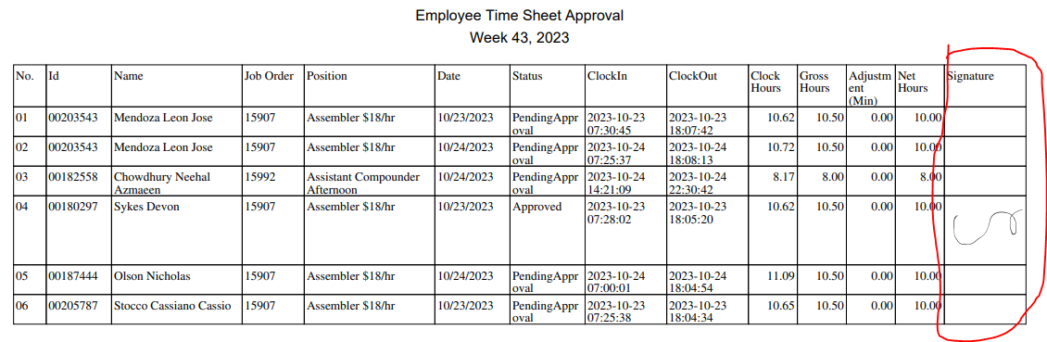

Otherwise, the printed PDF doesn’t have signature column.

